A Study of John 2:13-25

¹³ The Passover of the Jews was at hand, and Jesus went up to Jerusalem. ¹⁴ In the temple he found those who were selling oxen and sheep and pigeons, and the money-changers sitting there. ¹⁵ And making a whip of cords, he drove them all out of the temple, with the sheep and oxen. And he poured out the coins of the money-changers and overturned their tables. ¹⁶ And he told those who sold the pigeons, “Take these things away; do not make my Father’s house a house of trade.” ¹⁷ His disciples remembered that it was written, “Zeal for your house will consume me.” ¹⁸ So the Jews said to him, “What sign do you show us for doing these things?” ¹⁹ Jesus answered them, “Destroy this temple, and in three days I will raise it up.” ²⁰ The Jews then said, “It has taken forty-six years to build this temple, and will you raise it up in three days?” ²¹ But he was speaking about the temple of his body. ²² When therefore he was raised from the dead, his disciples remembered that he had said this, and they believed the Scripture and the word that Jesus had spoken. ²³ Now when he was in Jerusalem at the Passover Feast, many believed in his name when they saw the signs that he was doing. ²⁴ But Jesus on his part did not entrust himself to them, because he knew all people ²⁵ and needed no one to bear witness about man, for he himself knew what was in man.

This story follows the previous story not because it follows chronologically. Instead, John is building on the main point of the first sign – Jesus came to make all things new. Keep this in mind as we study these Scriptures. The focus is not on what Jesus is doing, but what His actions and words are communicating.

Like the water-into-wine miracle in Cana, less important details in this story can distract us from the main message. Here are some common distractions:
- Is this the same story that we find in the other gospels or did Jesus do this more than once?
- Is Jesus justifying the use of force?
- Is this a righteous anger or righteous indignation? What are the criteria for that in case we need to justify our anger or indignation?

A similar story is told in the other gospels – Matthew 21:12-13, Mark 11:15-17, Luke 19:45. All are shorter accounts and all appear to occur near the end of Jesus’s earthly ministries. There are different theories as to why John put the story near the beginning of his gospel.

¹³ The Passover of the Jews was at hand, and Jesus went up to Jerusalem. The setting is Jerusalem during the Passover feast. What could we assume about the setting based on these two details?
¹⁴ In the temple he found those who were selling oxen and sheep and pigeons, and the money-changers sitting there.

The setting is specified further – the temple in Jerusalem. This was the most sacred site in Jerusalem at the most sacred time. The next page has a drawing of the temple during this time. It had been under reconstruction since the time of King Herod about three decades earlier. It would not be completed until AD 63. It would be destroyed by the Romans in AD 70.

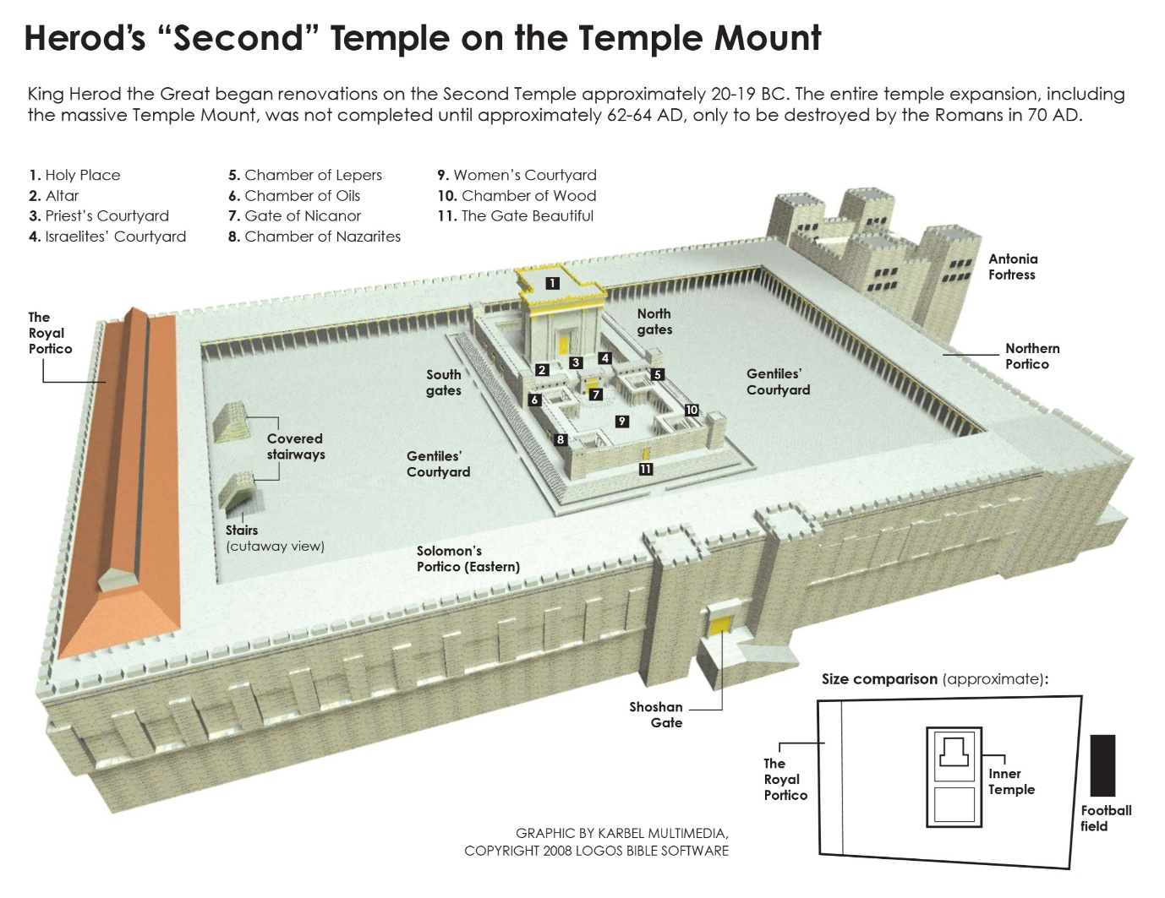
The sellers of sacrificial animals and changers of money would have likely been located in the portico.

Why would they need to sell animals at the temple?

Why would there need to be money changers at the temple?

Notice the difference in how Jesus encountered the sellers of sheep and oxen and the sellers of pigeons. What could be some of the reasons for the differences? How could Leviticus 5:7 help explain this?

In this account, John does not indicate that the sellers and money changers are doing anything unethical or illegal. (In the other accounts, Jesus says they have made the temple “a den of robbers.”) Jesus gives the reason for clearing the temple – “… do not make my Father’s house a house of trade.” A more general principle would be: “Do not make my Father’s house anything that takes away from its purpose.” The focus is not on the sin of man, but on the purpose of the temple. We will soon see why John is focusing on the temple.
(Zechariah 14:20-21, Micah 6:6-13, Jeremiah 7:4)

¹⁷ His disciples remembered that it was written, “Zeal for your house will consume me.” ¹⁸ So the Jews said to him, “What sign do you show us for doing these things?” ¹⁹ Jesus answered them, “Destroy this temple, and in three days I will raise it up.” ²⁰ The Jews then said, “It has taken forty-six years to build this temple, and will you raise it up in three days?” ²¹ But he was speaking about the temple of his body. ²² When therefore he was raised from the dead, his disciples remembered that he had said this, and they believed the Scripture and the word that Jesus had spoken.

In verse 17, John noted that the disciples recalled a Scripture (Psalm 69:9) that referred to the Messiah. But he moves on to the Jewish leaders confronting Jesus and asking essentially: “On whose authority have you done this?” Jesus did not answer their question directly. What does Jesus say in response?

Verses 21-22 tell the readers what Jesus meant. What is He referencing in this statement?

Verse 20 is another example of people misunderstanding Jesus. What do they think He is referencing?

Ironically, the temple will be destroyed about 40 years later and it has not been rebuilt to this day.

In verses 21-22, John has told this story to shift his readers’ focus to the true point of the story. What has Jesus changed with regards to God’s temple?

Just as we saw in the previous story, Jesus came to make all things new. The New Covenant builds on the Old Covenant, but it is new. What are some of the implications of this new understanding of the temple in the New Covenant?

What could the driving out of the animals have signified regarding what Jesus will accomplish in the New Covenant? In other words, why would they no longer be needed at the temple?

Jesus had come to restore true worship of God. When He says, “do not make my Father’s house a house of trade,” He presumes that His hearers know what the temple was supposed to be. But then Jesus radically changed all that. With what we have learned from this passage, what must true worship of God ALWAYS involve? Remember that true sacrifice in the Old Testament could only occur at the temple.

²³ Now when he was in Jerusalem at the Passover Feast, many believed in his name when they saw the signs that he was doing. ²⁴ But Jesus on his part did not entrust himself to them, because he knew all people ²⁵ and needed no one to bear witness about man, for he himself knew what was in man.

These last verses are saddle verses – finishing the previous story and introducing the next. In the previous story, John had distinguished between just knowledge alone and knowledge and faith. Here John is making a distinction between believing that leads to salvation and just believing.

According to these verses, what effect must take place for believers to truly be disciples of Christ? In other words, what did Jesus know was in the heart of the true disciple and not in the heart of one who only believed?

REFLECTION
Jesus said that He knew what was “in man.” How is this both encouraging and perhaps troubling when we consider our own relationship to Him?

What does this tell us about what it means to be a new creation?

